**RentItNow**

**Rest API(POSTMAN) using MySQL:**

1.Register: Registering with the user

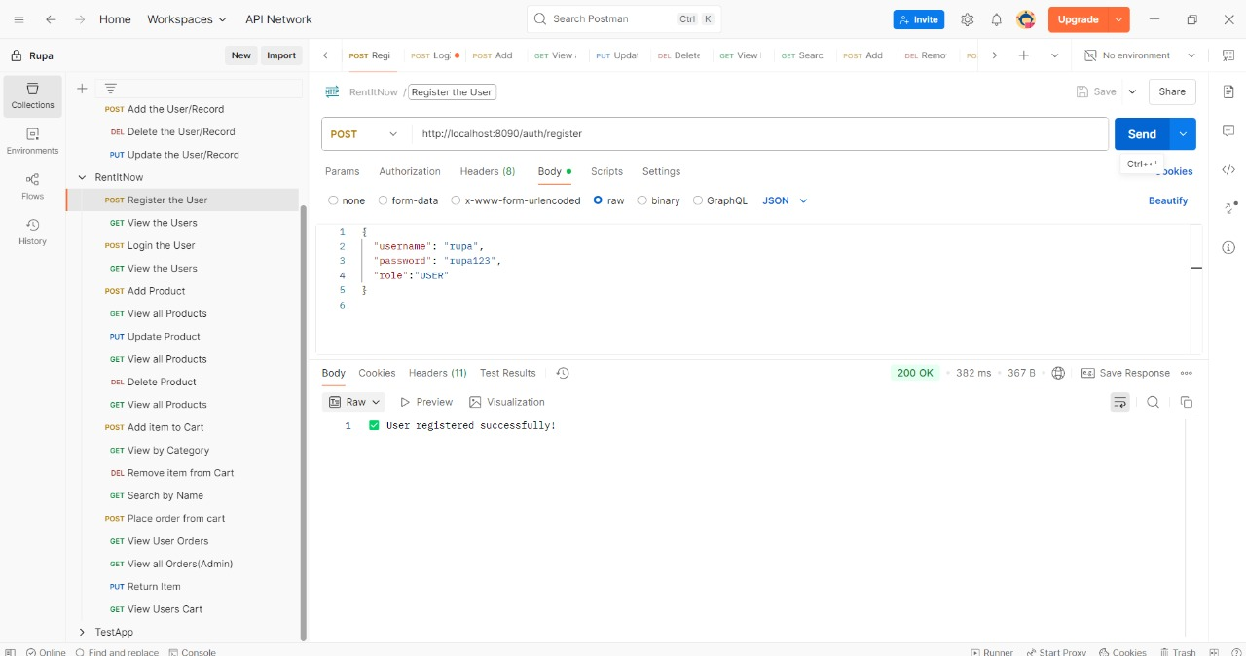

2.GET: To view the users

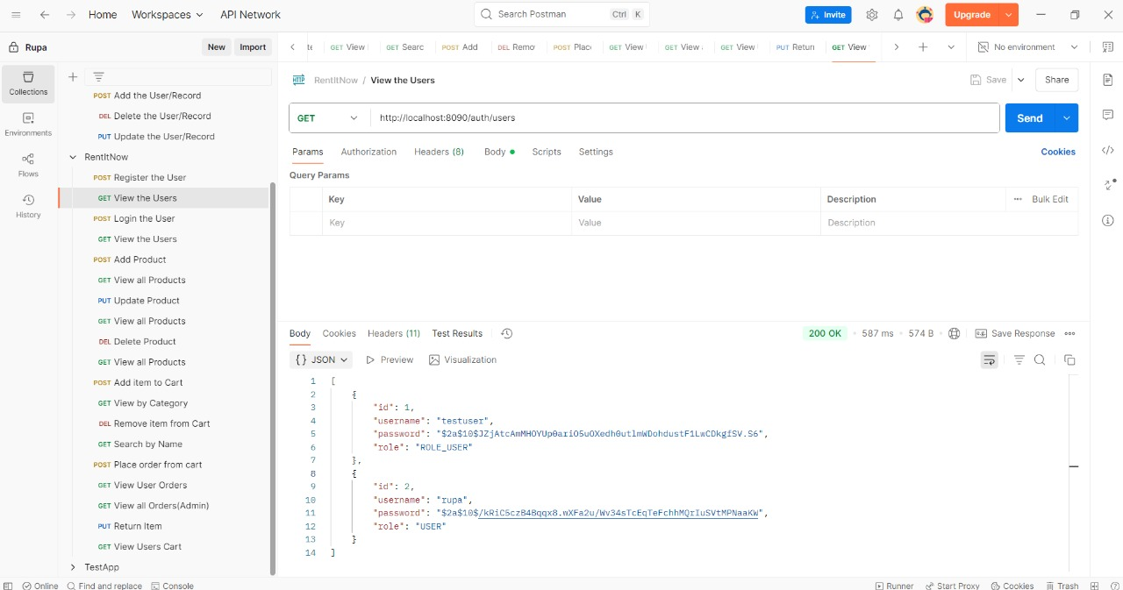

3.Login: Login with user

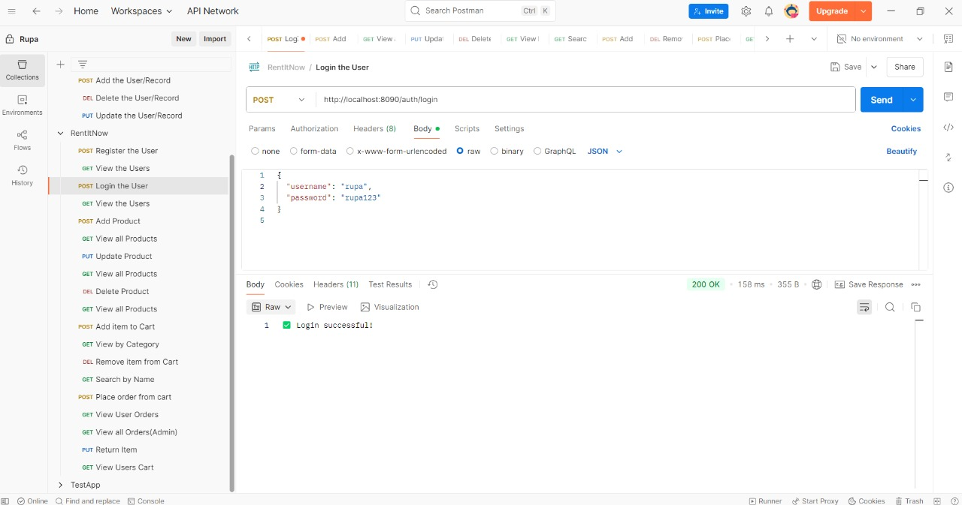

4 i) Structure of DataBase:

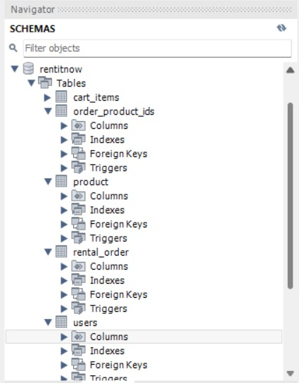

4 ii)After Register and login the data is stored in database(MySQL)

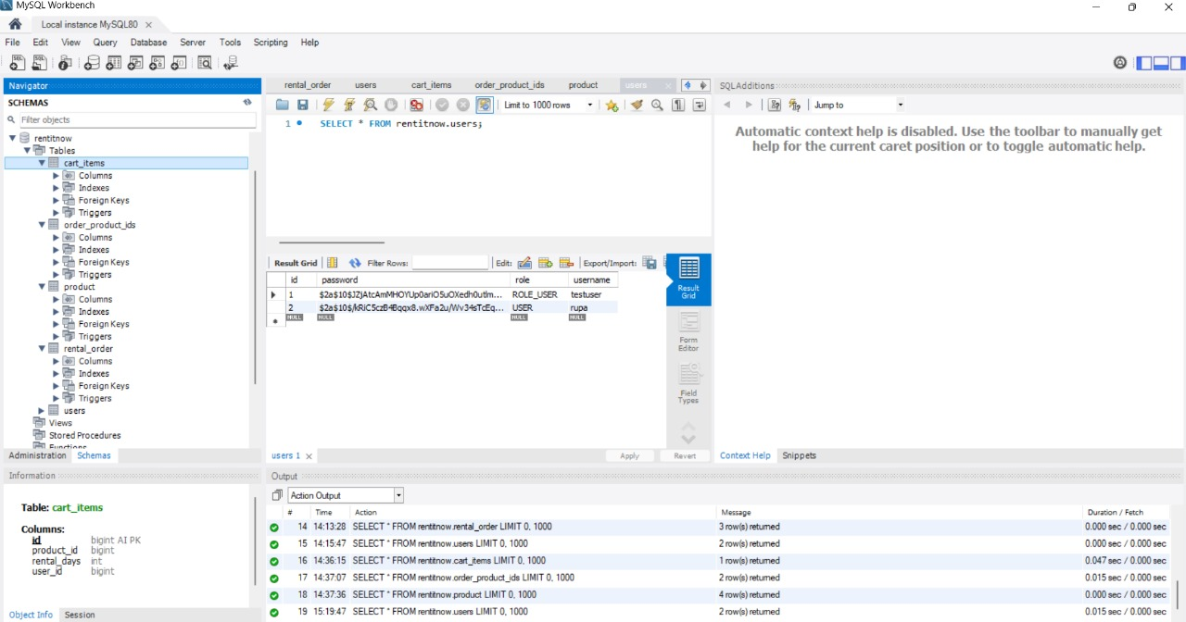

5.Adding product to the database:

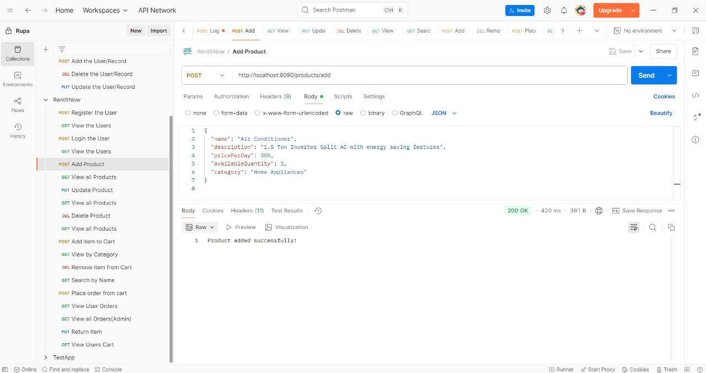

6.To view all products:

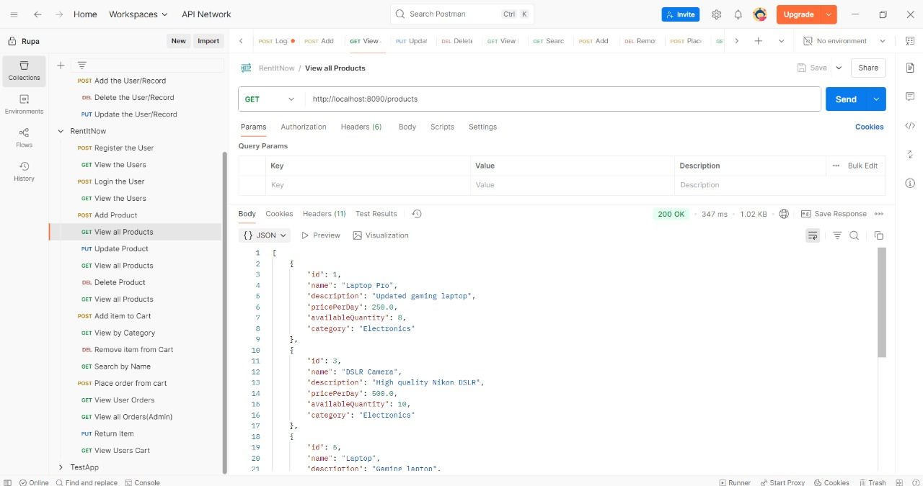

7.View products in the database whether the products added or not:

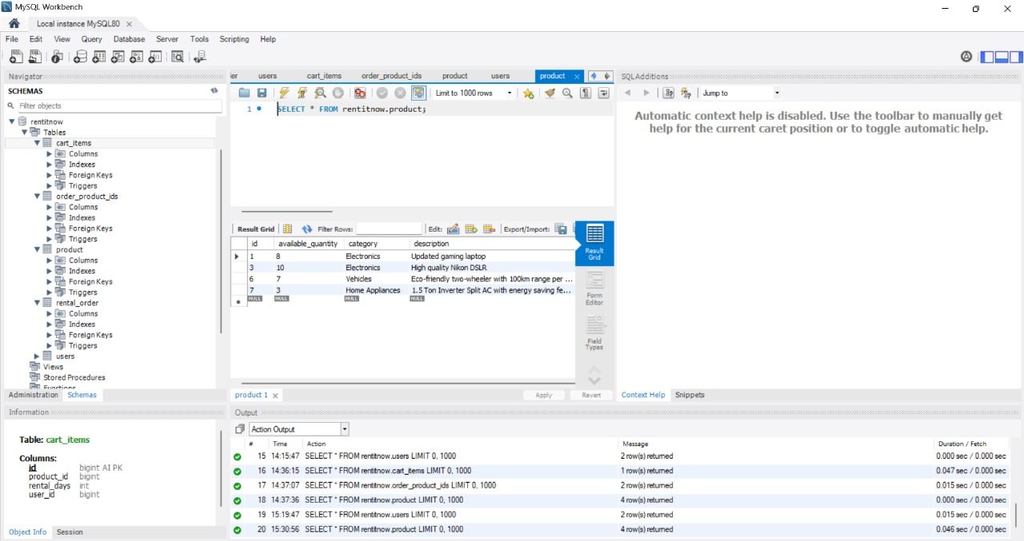

8.Updating products :

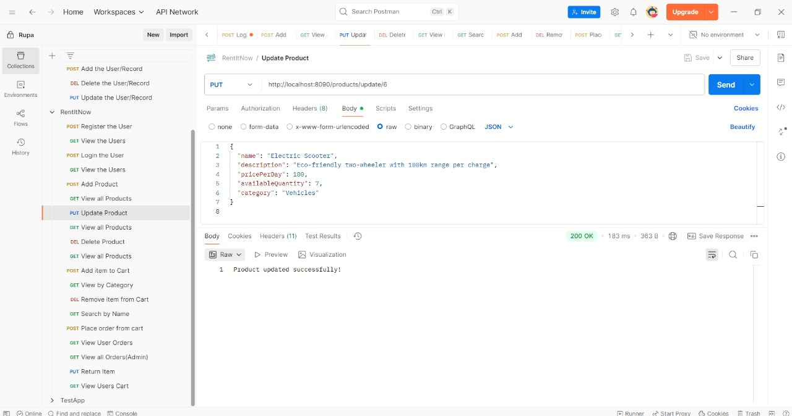

9.View all products after updating:

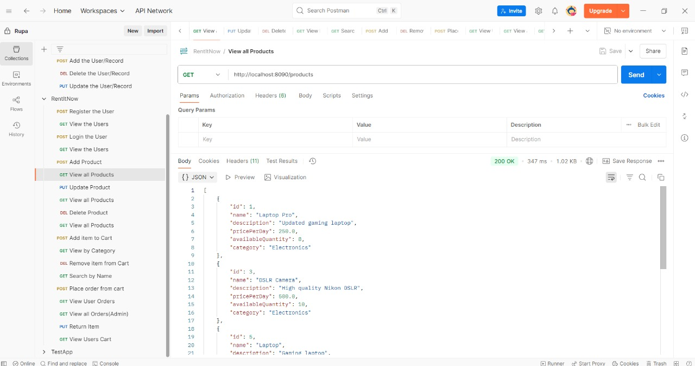

10.View all products in database after updation:

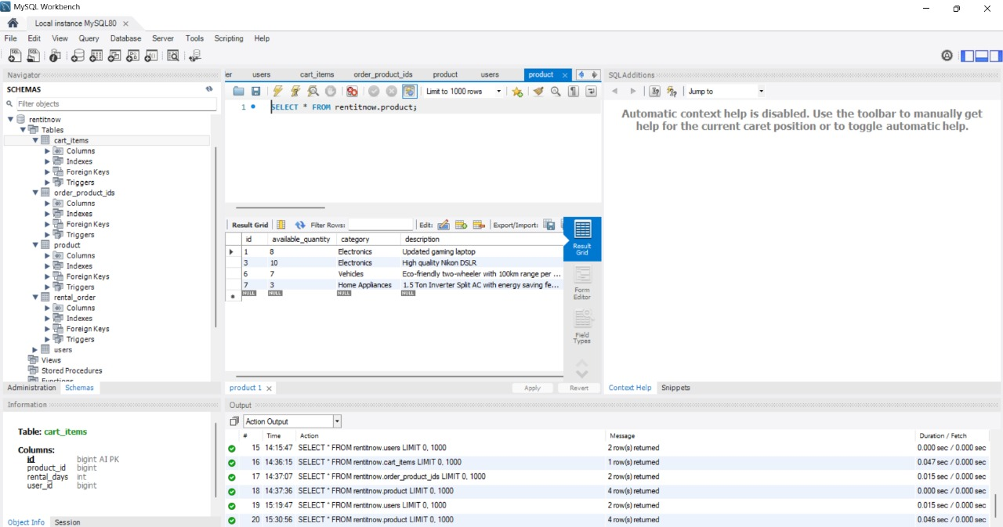

11.Deleting a Product:

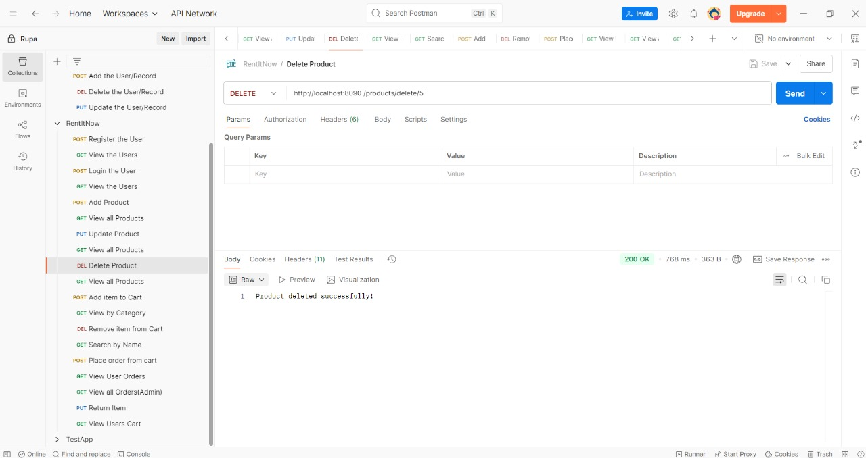

12.Checking whether the product is deleted or not in the database:



13.View all products after deleting in database:

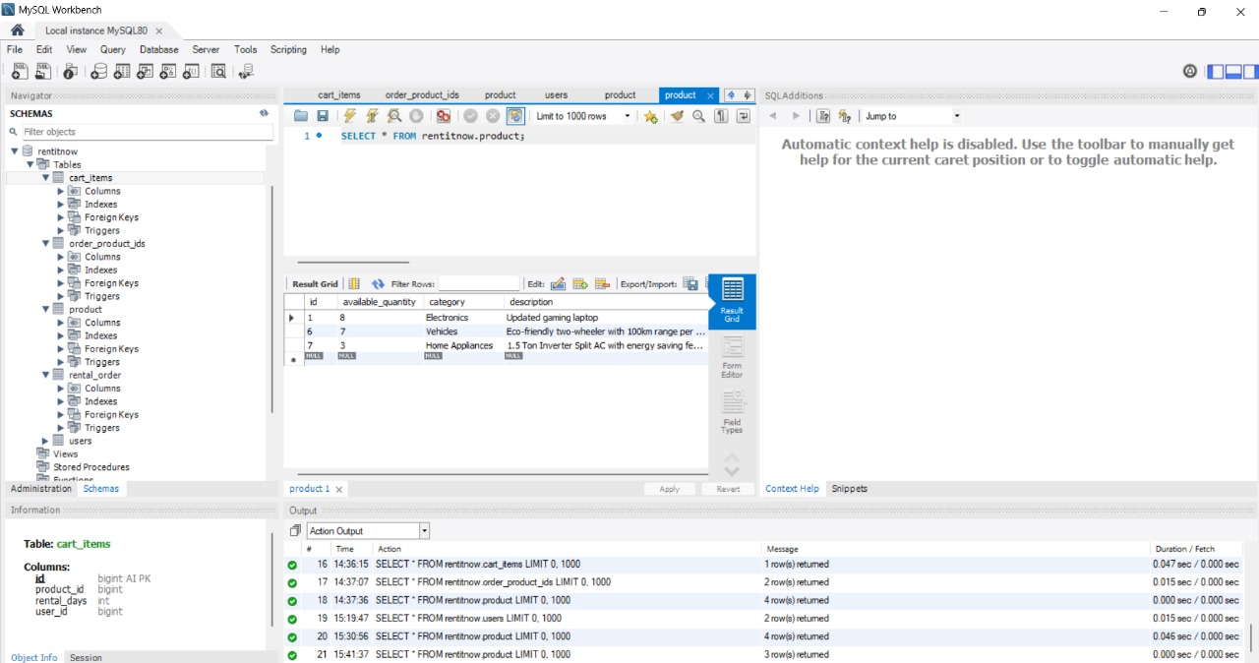

14.Add item to cart:

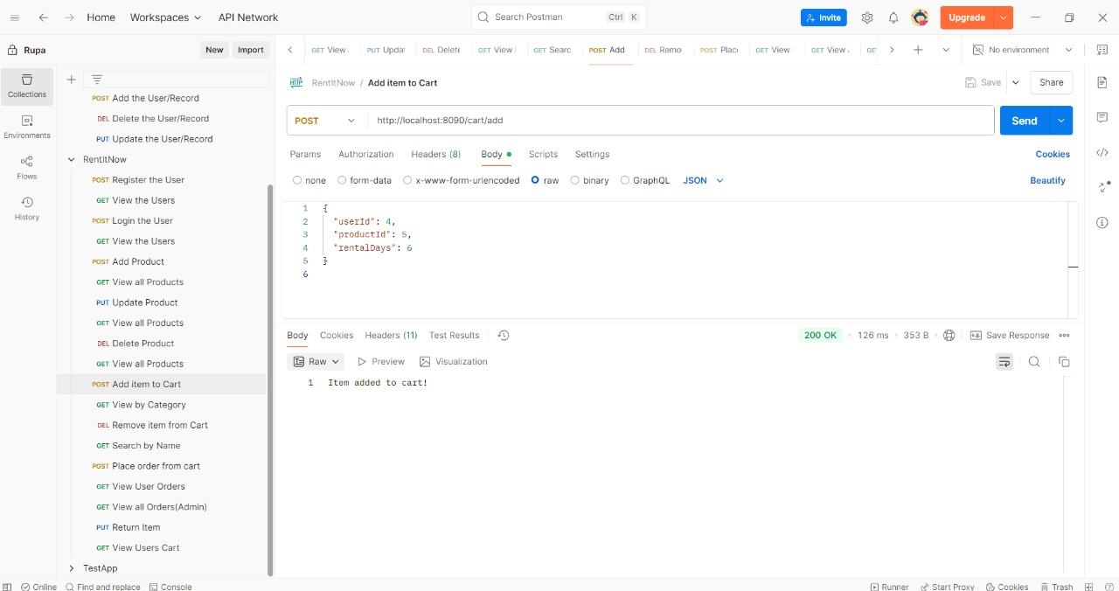

15.After adding the product to cart displaying in database:

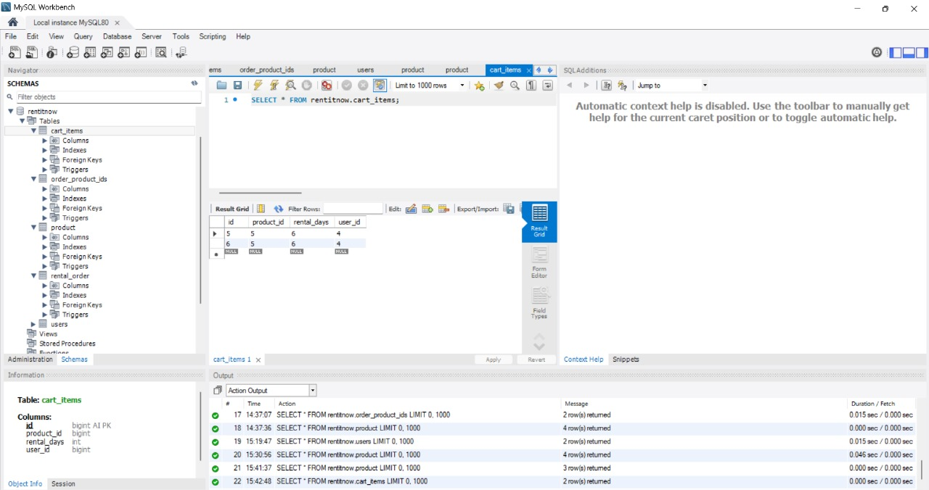

16. View by category :

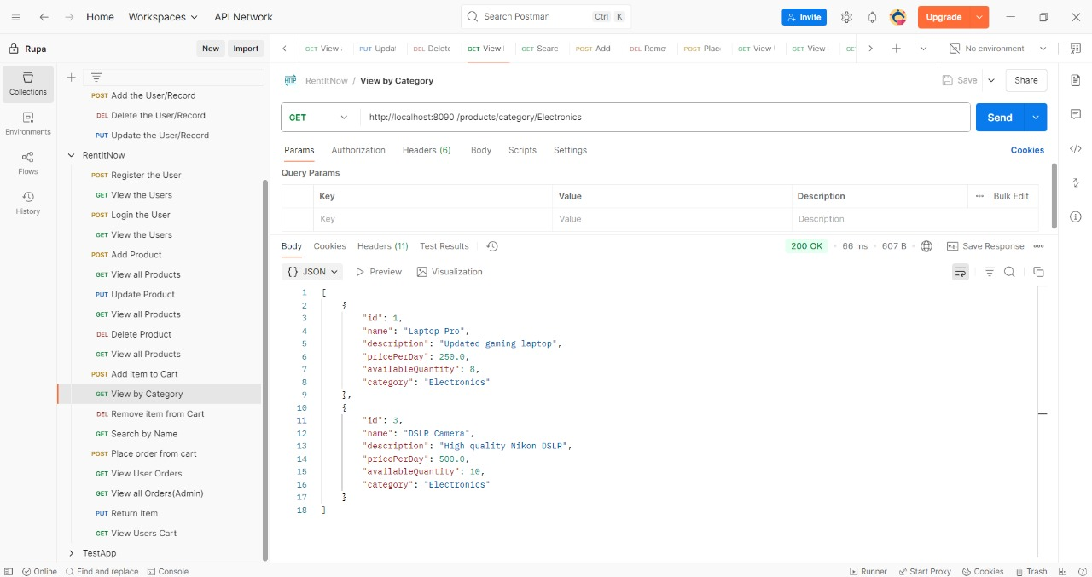

17.Removing an item from cart:

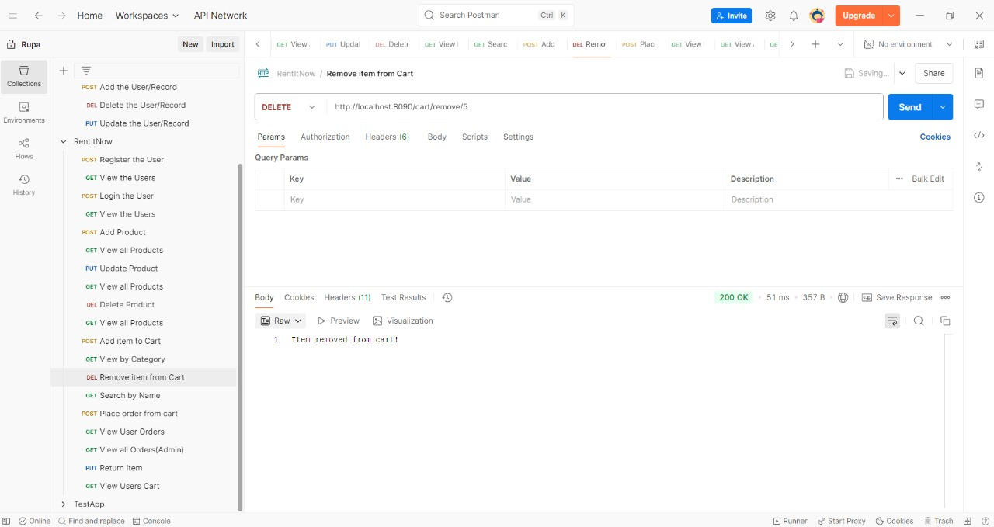

18.After removing items from cart showing in database:

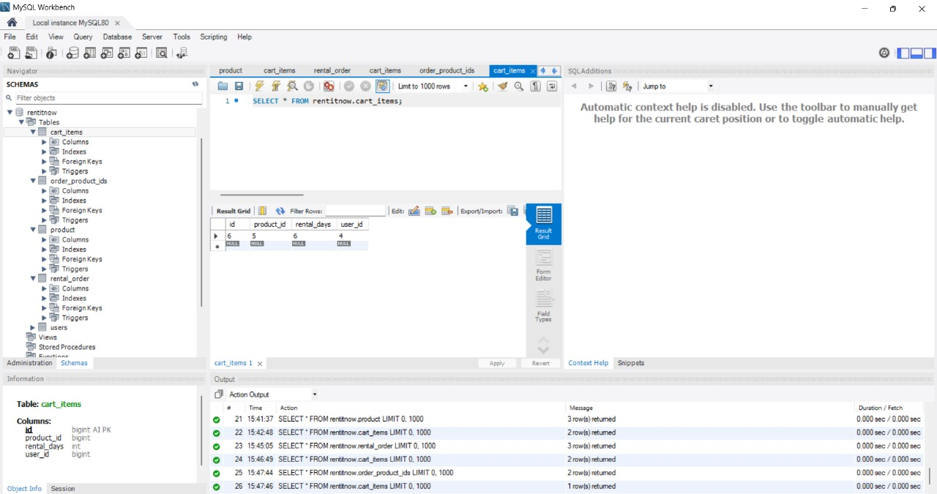

19.Viewing all products after removing items

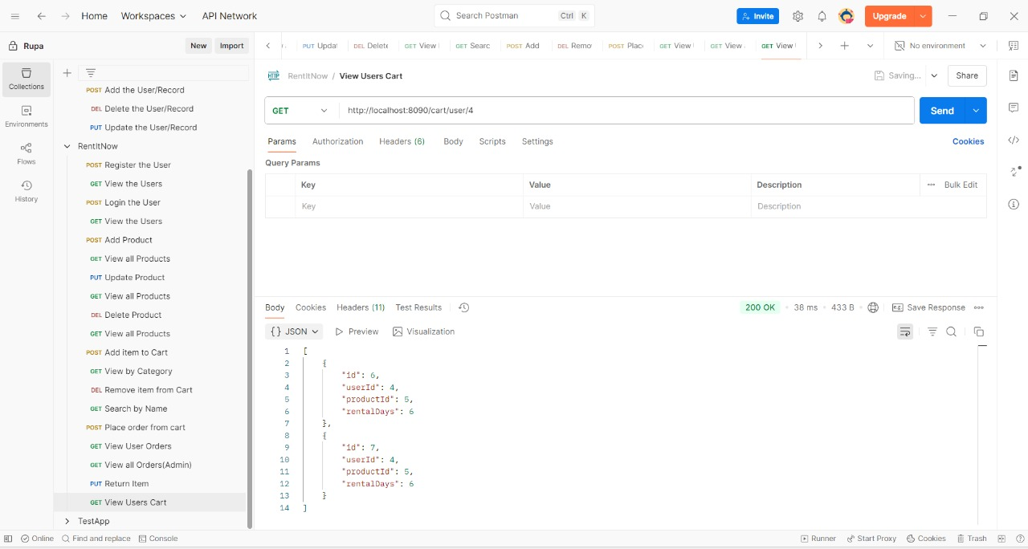

20.Getting product by searching name:

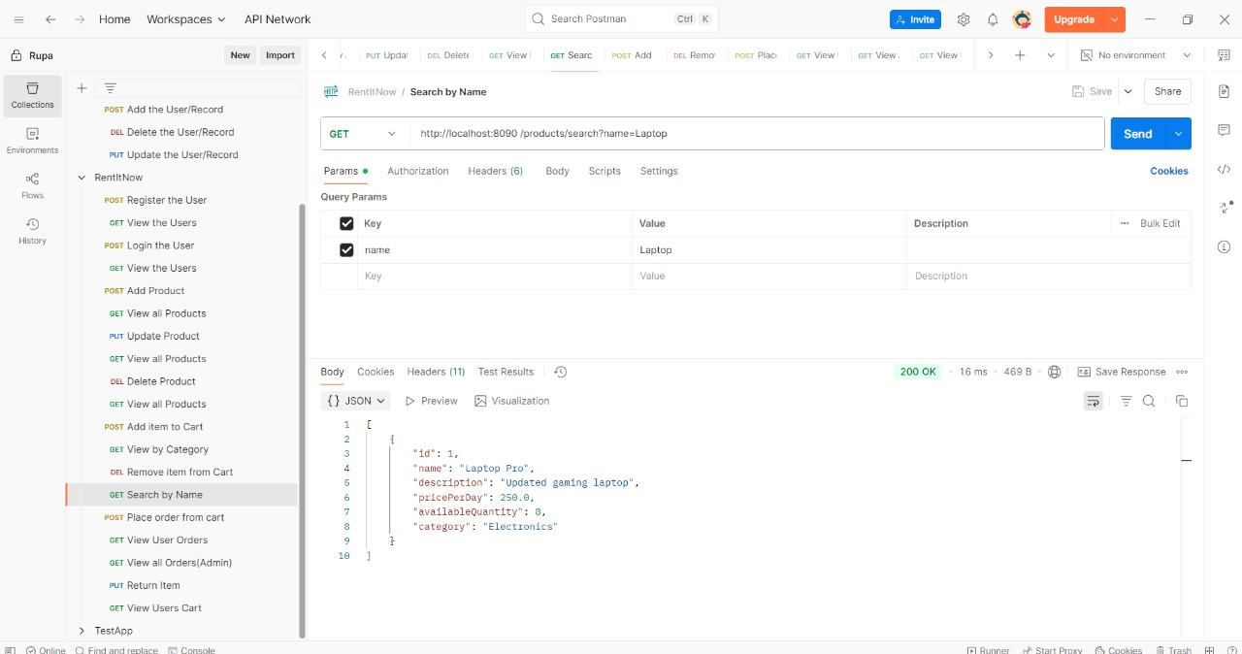

21.Place order from cart:

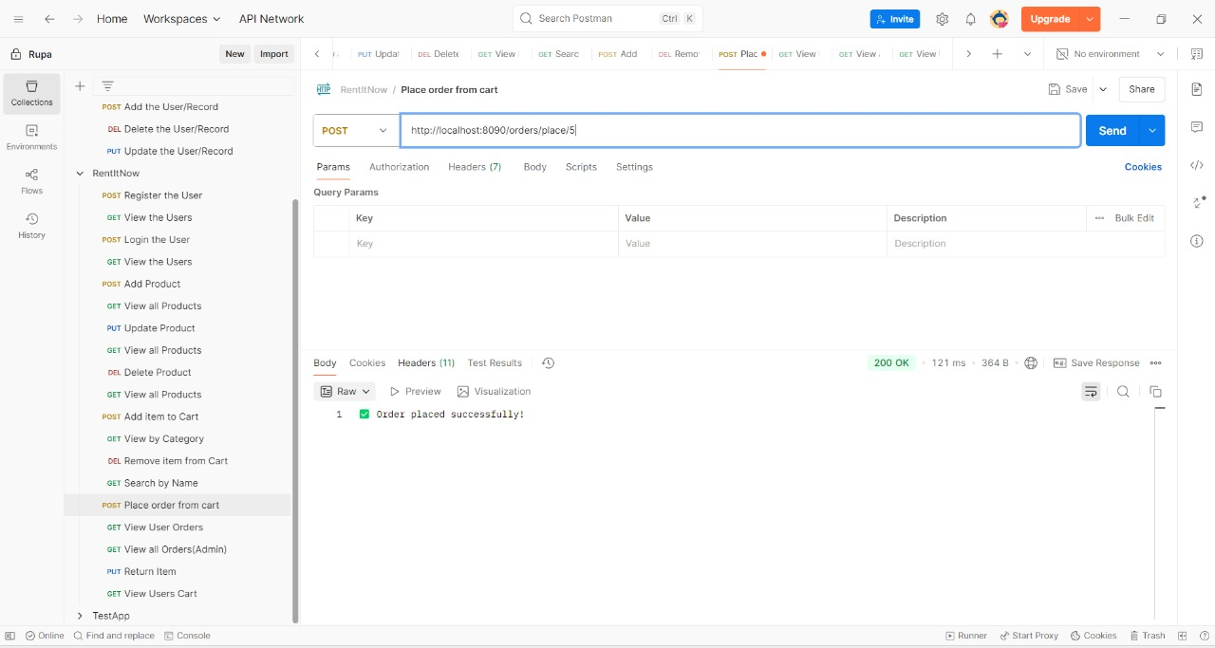

22.View User orders:

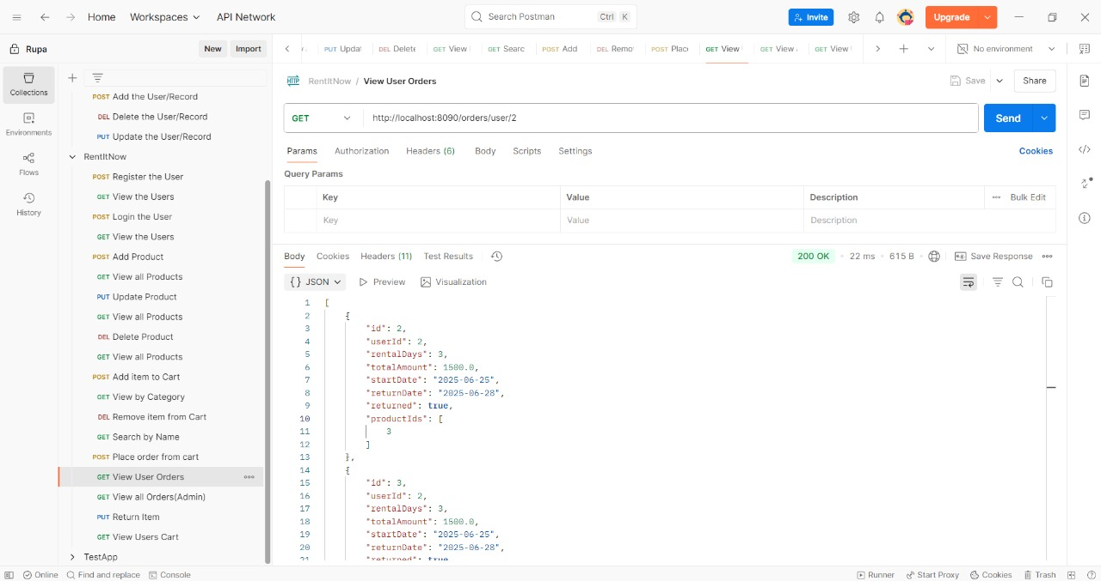

23.View all orders (Admin):

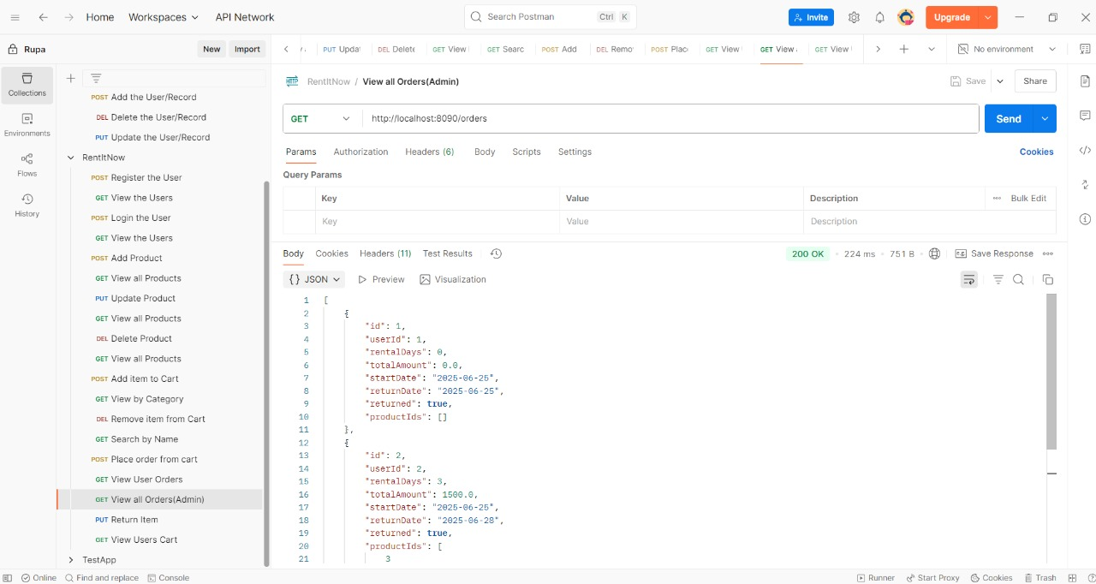

24.Viewing all products in database:

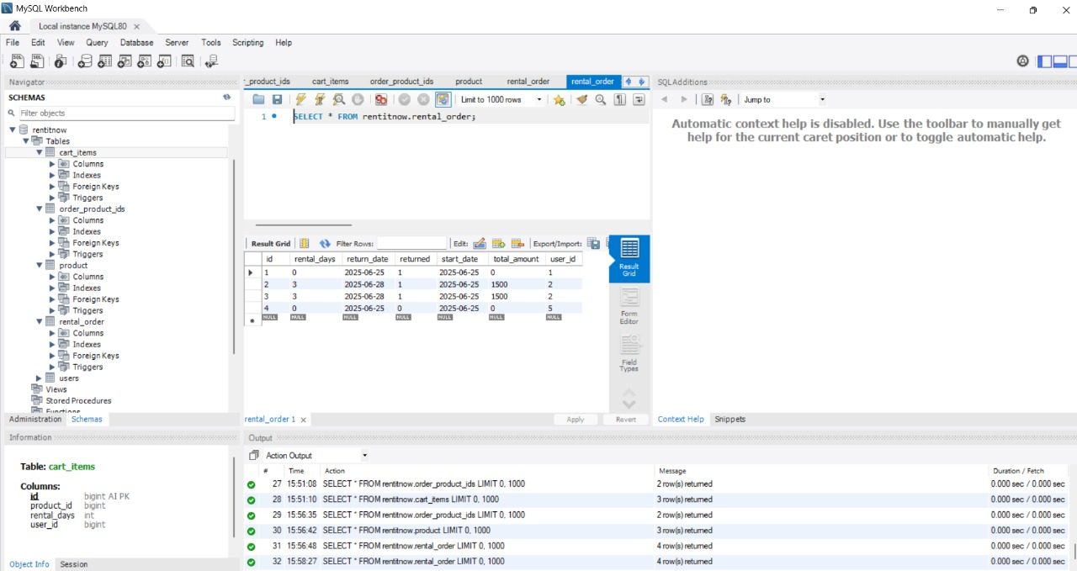

25. Return Item:

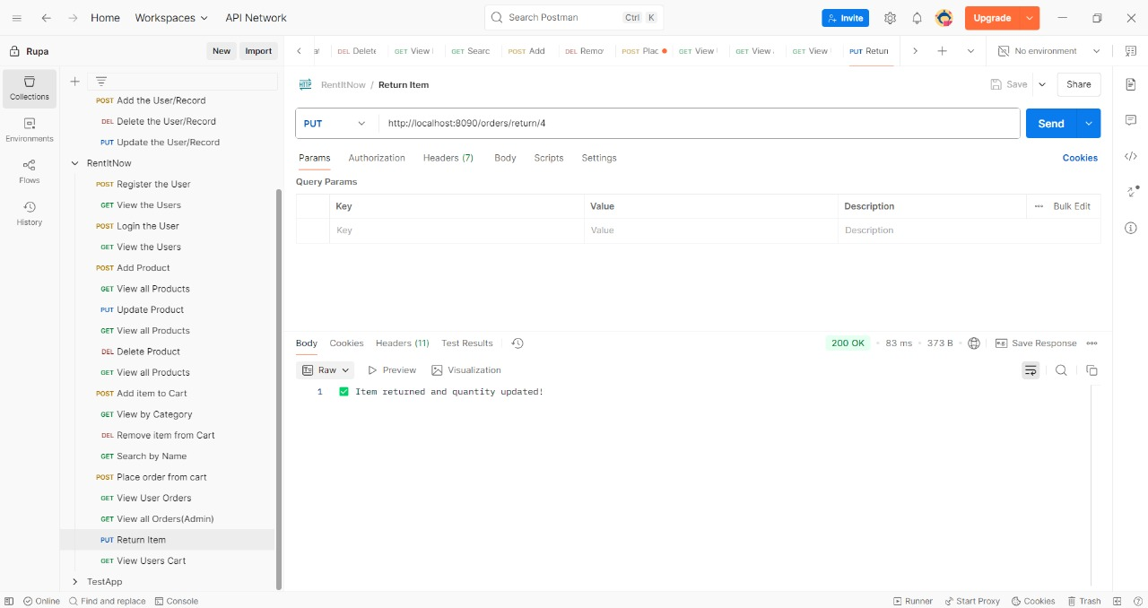

26.Return item , showing in database:

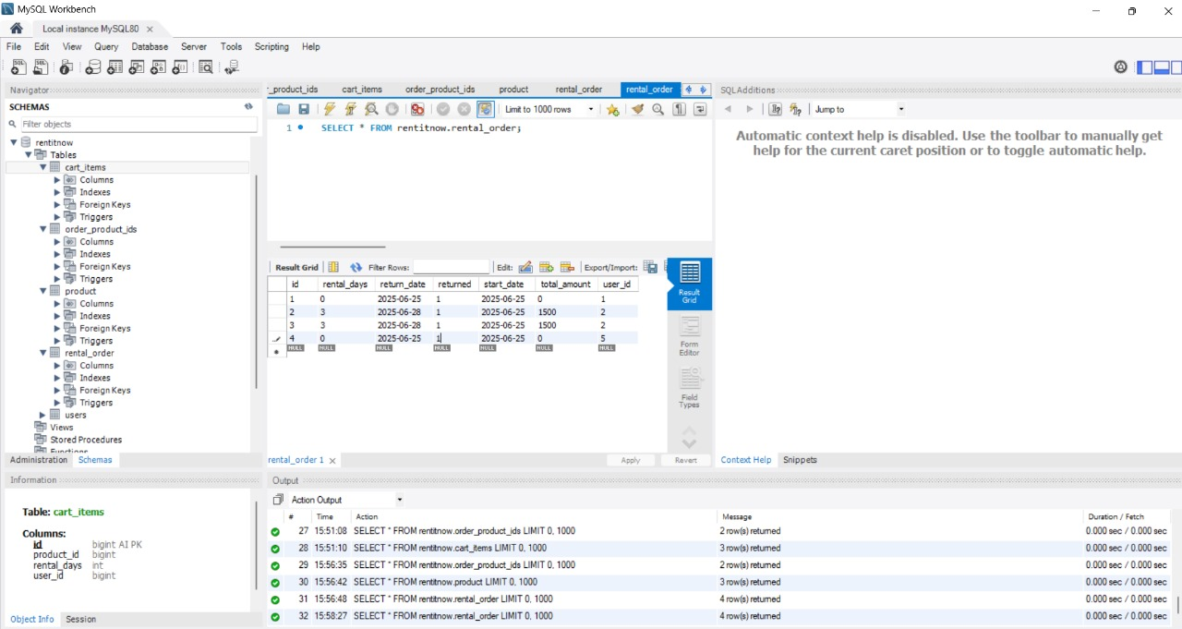

27.View users cart after returning item:



**Spring using Spring Tool Suite:**

1.Project structure and codes:

